 **THE GOSLINGS PRESCHOOL** **REGISTRATION** **FORM**

(This needs to be completed before your child’s first day)

|  |  |  |  |
| --- | --- | --- | --- |
| Start Date: |  | | |
| Child’s Name: |  | | |
| Known as: |  | Date of Birth: |  |
| Religion: |  | Ethnic Origin: |  |
| First/Home Language: |  | | |
| Details of any Disability: |  | | |
| Access Requirements: |  | | |
| Names of Parents/Person(s)  holding Parental Responsibility: |  | | |
| Home Address: |  | | |
| Home Telephone: |  | | |
| Mobile: |  | | |
| Email: |  | | |
| Work Address: |  | | |
| Work Telephone: |  | | |

**ADDITIONAL** **EMERGENCY** **CONTACT** **NUMBERS**

|  |  |  |  |
| --- | --- | --- | --- |
| Name: |  | Telephone: |  |
| Relationship to Child: |  | Mobile: |  |
| Name: |  | Telephone: |  |
| Relationship to Child: |  | Mobile: |  |
| Name: |  | Telephone: |  |
| Relationship to Child: |  | Mobile: |  |

|  |  |
| --- | --- |
| Who will usually collect your child from preschool: |  |

**EMERGENCY** **PASSWORD** (To give to the person authorised in an emergency situation, to pick up your child. A child will only be released to anyone who gives the password or is named on the registration form and known to the staff at The Goslings Preschool unless prior written consent is provided).

|  |  |
| --- | --- |
| Password: |  |

**MEDICAL** **INFORMATION**

|  |  |
| --- | --- |
| Important Medical Conditions:  (e.g. Allergies, Convulsions, etc.) |  |
| Injections Received: |  |
| Is there anything else preschool should know about your child: |  |
| Do you have any SEN worries or concerns about your child: |  |

**DOCTOR’S** **DETAILS**

|  |  |
| --- | --- |
| Child’s Doctor’s Name: |  |
| Address: |  |
| Telephone: |  |

I give my consent for my child to receive any medical treatment which is urgently needed

**DENTIST** **DETAILS**

|  |  |
| --- | --- |
| Child’s Dentist’s Name: |  |
| Address: |  |
| Telephone: |  |

I give my consent for my child to receive any medical treatment which is urgently needed

**DIETARY** **INFORMATION**

|  |  |
| --- | --- |
| Any special Dietary Requirements: |  |
| Does your child drink semi-skimmed milk, if they need any different milk are you happy to provide, please state what they have: |  |

**ANY OTHER RELEVANT INFORMATION**

|  |  |
| --- | --- |
| Is your child subject to a CIN/CP plan, Does your child have a social worker/family service worker?  I understand that any other carer who suspects that a child in his/her care has been abused or neglected has a duty to report this to Social Services Department. |  |

|  |  |  |  |  |  |  |  |  |  |
| --- | --- | --- | --- | --- | --- | --- | --- | --- | --- |
| **Monday** | | **Tuesday** | | **Wednesday** | | **Thursday** | | **Friday** | |
| **Morning**  **9.00-12.00** |  | **Morning**  **9.00-12.00** |  | **Morning**  **9.00-12.00** |  | **Morning**  **9.00-12.00** |  | **Morning**  **9.00-12.00** |  |
| **Afternoon**  **12.00-3.00** |  | **Afternoon**  **12.00-3.00** |  | **Afternoon**  **12.00-3.00** |  | **Afternoon**  **12.00-3.00** |  | **Afternoon**  **12.00-3.00** |  |

|  |
| --- |
| Invoices will be given at the start of each term and your total amount will be split over three months,  you then have the option to pay in full or split over the three months to help you financially.  I understand that I may need to pay a £50.00 deposit to hold a place, this will be offset against your  first payment of fees, or refunded if you are claiming Free Early Education Entitlement for your child.  If your child is to leave preschool for any reason 4 weeks written notice is required,  and I understand that all fees due for the term must be paid before leaving.  I will complete the declaration form for the Free Early Education Entitlement  when required, ensuring that it is completed accurately and understand that I may be  asked to pay for any losses incurred by the preschool as result of a misleading claim.  I will make sure that any fees owing will be paid for before each new term begins and I am  aware of charges that I may incur by delayed payments. Legal proceedings will be used in  non-payment of fees and my child’s place at The Goslings might not be held for the next term.  I have read and understood the The Goslings Preschool policies and procedures on the website: ([www.thegoslingspreschool.com/policies-documents](http://www.thegoslingspreschool.com/policies-documents))  By signing this registration form you are confirming that you have read and understand all policies, including the preschool Attendance Policy which outlines collection times and notifying of absences,  and the Child Protection and Safeguarding Policy which includes parent responsibilities.  Signed: ­­__________________________________________ Date: _____________________________ |

**PLEASE TICK WHICH SESSIONS YOU REQUIRE**

**GENERAL PERMISSION** **FORM**

In order to save time completing several permission slips, we ask you to complete the following.

I give permission for my child ________________________________ to participate in the following:

Halloween

Celebrating other cultures

Mothers Day and Fathers Day

Easter

Use of tablets and computer equipment

Nativity play

Food tasting and religion

Taken off the premises for a walk, wrist straps and hi-vis jackets will be provided

Activities with pets/animals

Nappy changing and toileting accidents

If your child attends another setting, you agree to us discussing any issues which we need to share

Can we speak to outside professionals if we have any concerns about your child?

Please state your Health Visitors Name: _____________________________________________________

Signed (Parent/Carer/Guardian): ________________________________ Date: ____________________

**Please could you ring preschool before 10.00am on the day, if they are unable to attend.**

**PHOTOGRAPH PERMISSION FORM**

Photographic evidence is an important part of recording your child’s journey at The Goslings Preschool. We regularly take photographs to record the children’s activities. These photographs may be used in the child’s learning journey that they will receive on their last day at The Goslings Preschool, they may also be used on the website or preschool social media.

All photographs of your child are stored either in your child’s learning journey or securely in our cloud based storage system, all images will be deleted once your child has left The Goslings Preschool.

**Please complete the form below to indicate your permission for this:**

**Please** **circle** **your** **answer:**

**YES NO** I give consent for my child’s photograph to be used in the preschool for displays.

**YES NO** I give consent for my child’s photograph to be used on the Preschool Website.

**YES NO** I give consent for my child’s photograph to be put on the Preschool Parents/Family

Facebook page.

**YES NO** I give consent for my child’s photograph to be on the newsletter or prospectus.

**YES NO** I give consent for my child’s photograph being published in the press **without** their name.

**YES NO** I give consent for my child’s photograph to be in their learning journey and to be used in

another child’s learning journey for any group observations.

**YES NO** I give consent for my child’s keyperson to have images of my child at their home to enable

them to complete their learning journey, the learning journeys are kept in a lockable box at

the house of the keyperson.

**YES NO** I give consent for my child’s photograph to be taken at Christmas, sports day and other

events, and I understand that I **cannot** post any photos on social media with any other child

in the photograph.

Child’s Name: ________________________________________________________________________

Parent/Carer/Guardian Name (PRINT): _____________________________________________________

Signature of Parent/Carer/Guardian: _____________________________________________________

Date: _________________________________

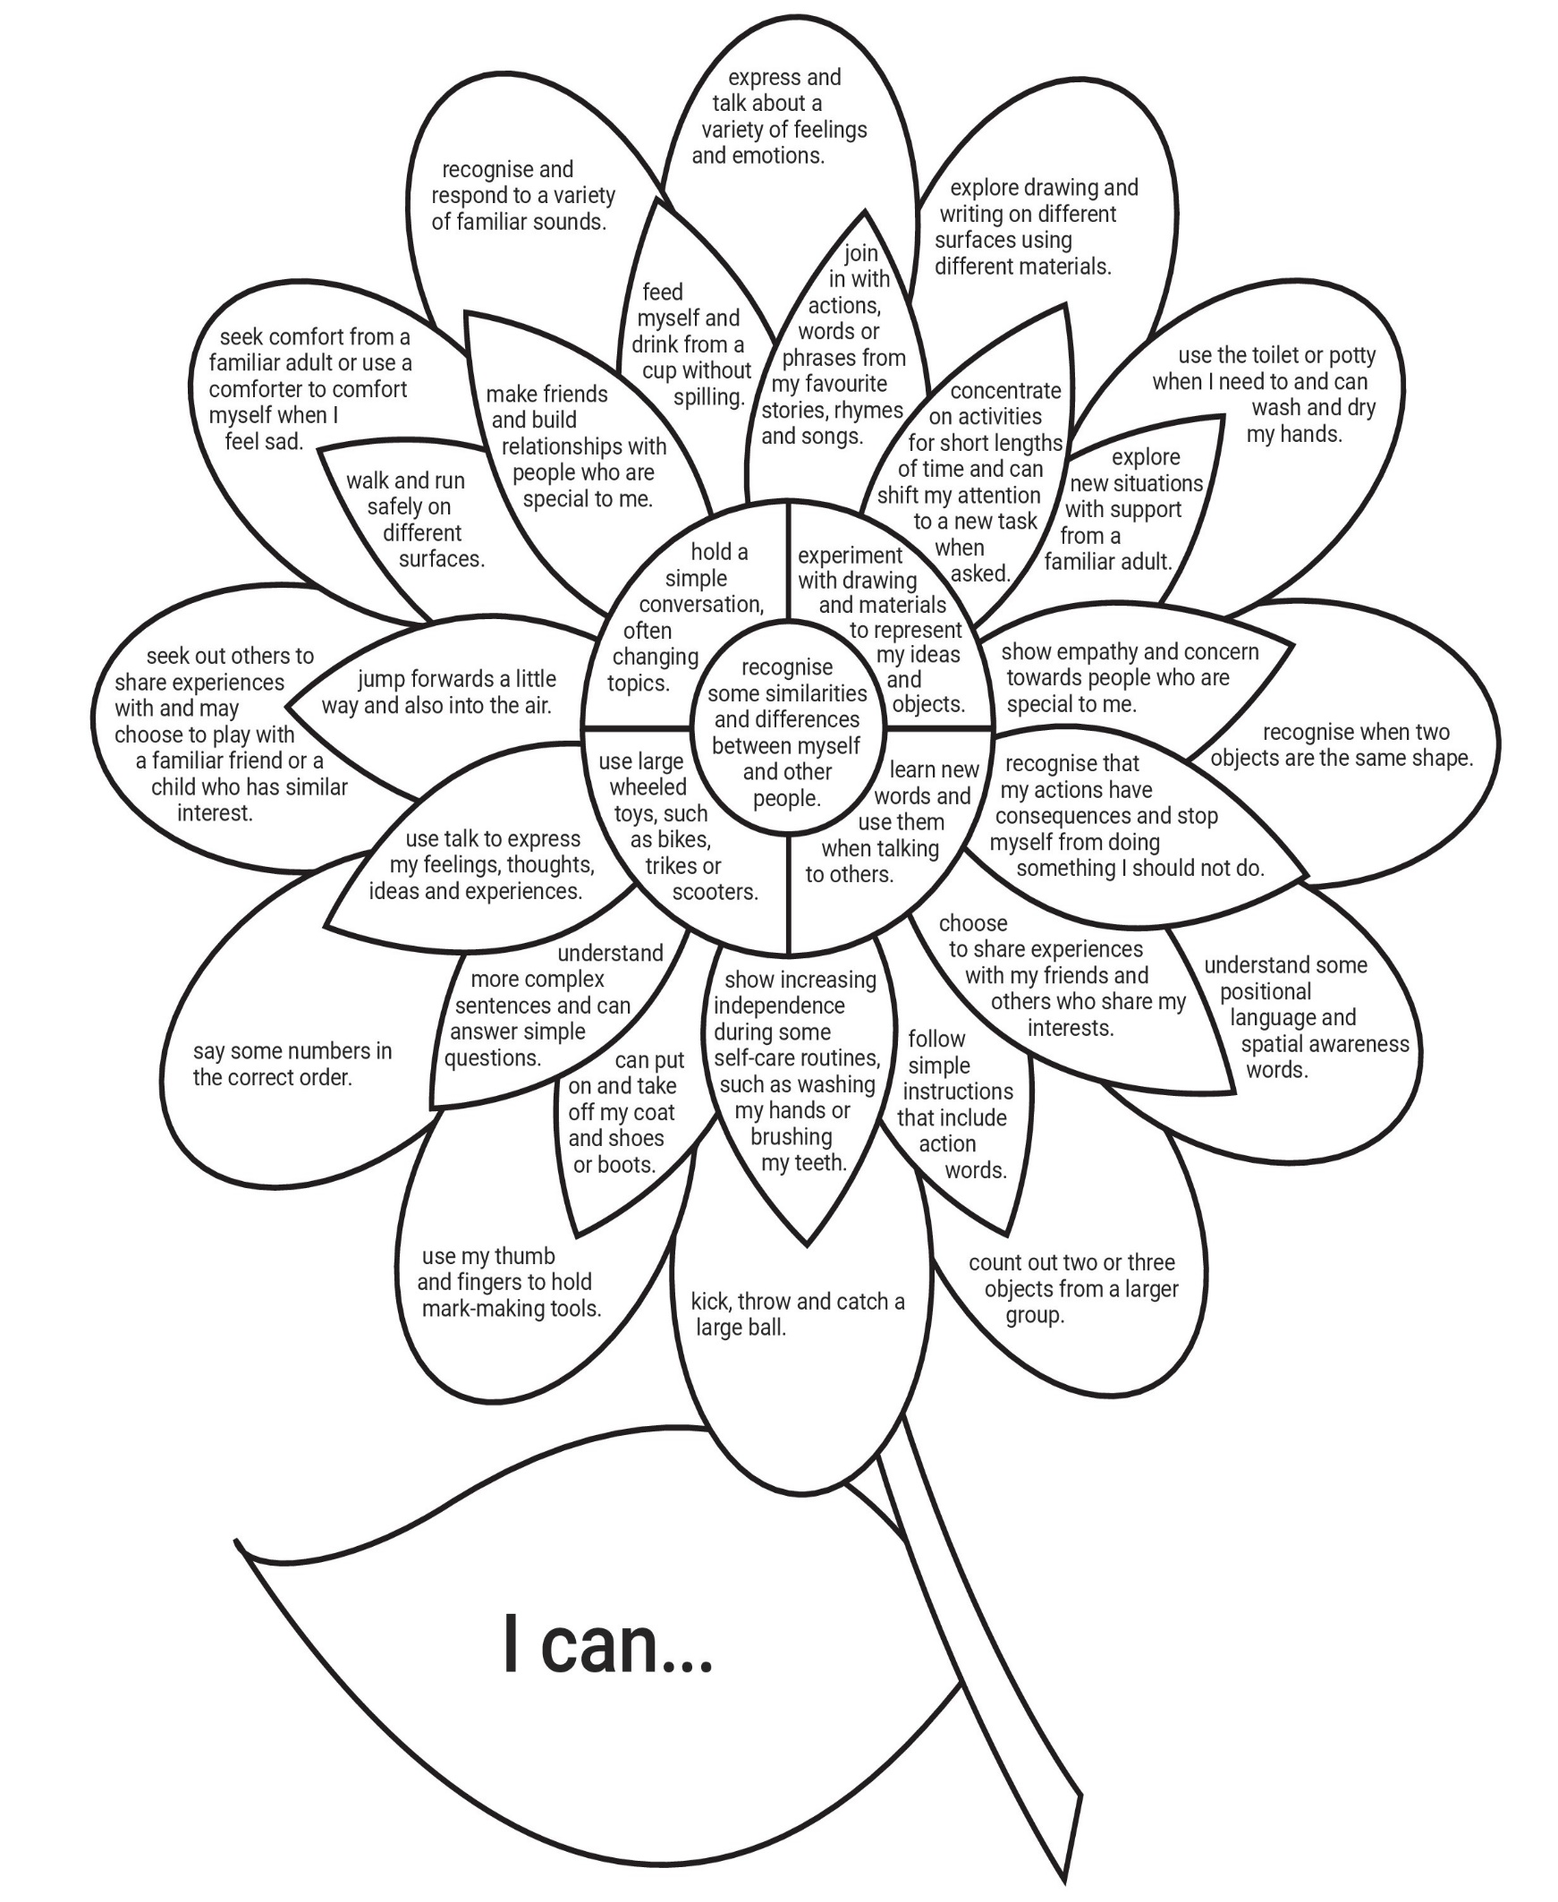

**I CAN ASSESSMENT - TWO TO THREE YEAR OLDS**

Please circle or highlight what your child can do and return to preschool with your starter pack.

**I CAN ASSESSMENT - THREE TO FOUR YEAR OLDS**

Please circle or highlight what your child can do and return to preschool with your starter pack.

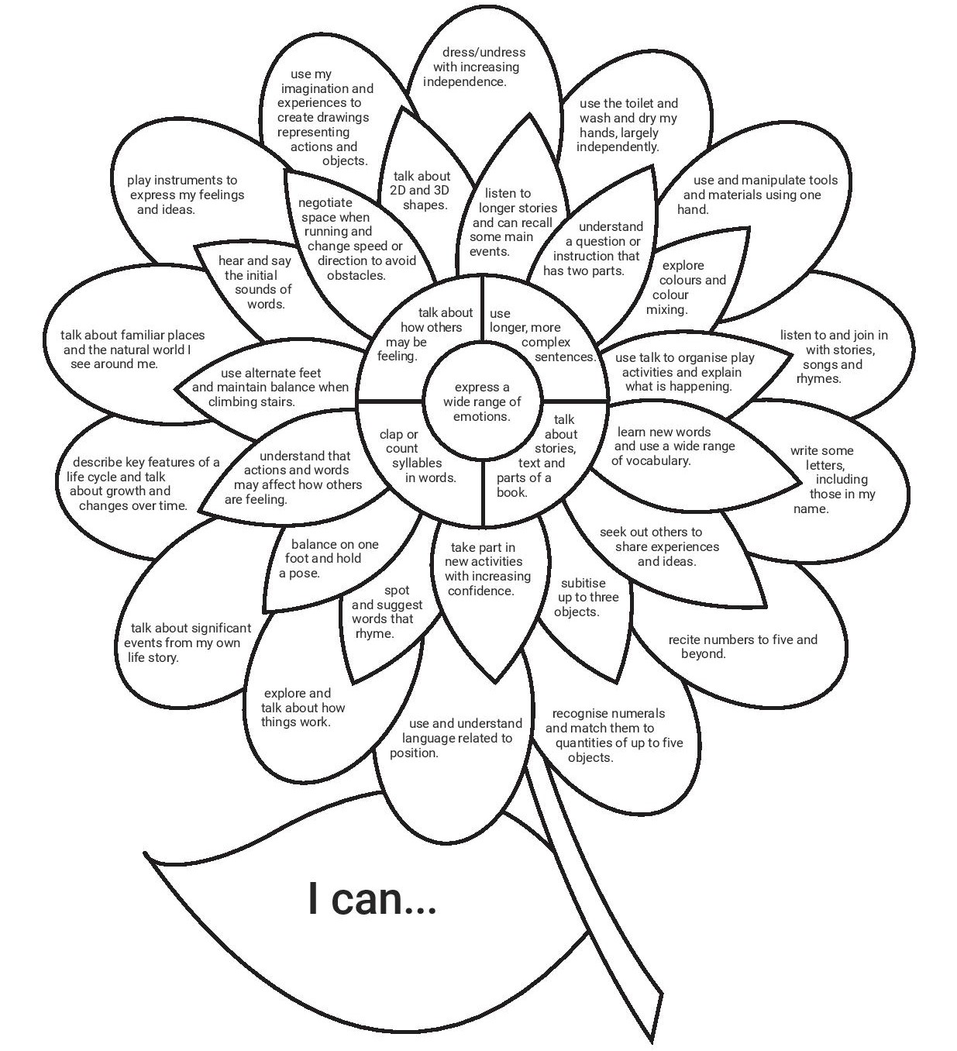

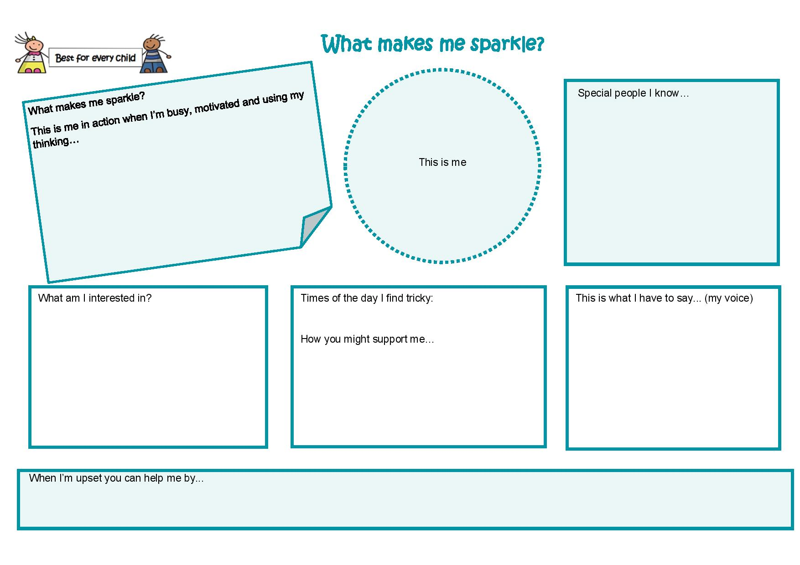

**SUNSCREEN POLICY AND DISCLAIMER**

**SUN** **SAFETY**

The Goslings Preschool believes in sun safety to ensure that children and staff are protected from skin damage.

* During the summer months we require all children to bring their own labelled sunscreen and sun hat to preschool to put in their blue bags.
* It is requested that before your child arrives sunscreen has already been applied (once a day creams are recommended).
* It is our policy that we can apply a generic 5 star sunscreen for emergency use, unless you have informed us of any allergies that your child may have.
* All children shall be kept out of the sun during the middle of the day and where possible all children will be encouraged to play in the shade.
* If a child does not have sunscreen on they will not be permitted to go outside (unless you sign to say that your child does not wear sunscreen).
* Parents/Carers must be given a sunscreen consent form.
* All staff have been briefed on the correct application of sunscreen and take the upmost care to ensure complete coverage. Staff use different disposable gloves for each child, or wash their hands effectively between applications of different sunscreens.
* Sunscreen will be reapplied to all children at lunchtime, or whenever needed during the day.
* Parents should ensure that children are dressed in suitable clothing and that shoulders are covered during warmer months, sunglasses are optional.

I have read the above instructions and agree to provide sun protection for my child.

I **agree** to apply the sunscreen to my child prior to their arrival on the days as appropriate and will send in a labelled sunscreen bottle and hat.

I **agree** to the staff re-applying sunscreen at lunchtime and whenever needed during the day.

Child does not need Sunscreen: ________________________________

Childs Name: _______________________________________________

Signed: ___________________________________________________

Print Name: ________________________________________________

Date: _____________________________________________________